JAPANESE FILM WEEK 2018

Meeting Point Cinema, Sarajevo

1-4 March 2018; ENTRANCE IS FREE!

**WHEN THE CURTAIN RISES – Thursday, 1 March –20:00h**

2015 / Blu Ray / 119 min.

Director: MOTOHIRO Katsuyuki

Cast: Momota Kanako, Tamai Shiori, Takagi Reni

An adaptation of Hirata Oriza's play by "Bayside Shakedown" series director Motohiro Katsuyuki. The members of idol group Momoiro Clover Z star as high school students who grow through their involvement in a lowly drama club. Among their co-stars is Kuroki Haru, who won a Silver Bear for Best Actress at the Berlin International Film Festival in 2014 for her performance in The Little House.

Fujigaoka High School's drama club has never made it past the preliminaries in regional competitions. Under the tutelage of Ms. Yoshioka (Kuroki), known as "the queen of school theater," the determined Saori (Momota Kanako) and her fellow clubmates band together in the hope of making the national championship.

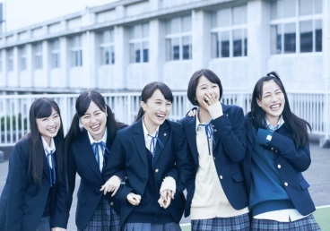

**ROUND TRIP HEART – Friday, 2 March – 20:00h**

2015 / Blu Ray / 97 min.

Director: TANADA Yuki

Cast: Oshima Yuko, Okura Koji, Nozaki Yoshimi

Road movie about the Romance Car limited express train operated by Odakyu Railways between Shinjuku and Hakone. Director Tanada Yuki's Mourning Recipe was an official selection at the 37th Montreal World Film Festival. Oshima Yuko plays the lead.

Hachiko (Oshima) works as a train attendant on the Romance Car and meets a suspicious passenger (Okura Koji) who claims to be a film producer. The guy happens to see a letter from her estranged mother, which leads to a sojourn to seek out her mother in Hakone.



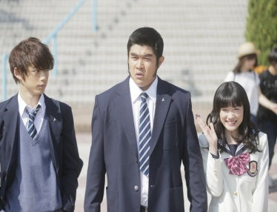

**MY LOVE STORY!! – Saturday, 3 March – 20:00h**

2015 / Blu Ray / 105 min.

Director: KAWAI Hayato

Cast: Suzuki Ryohei, Nagano Mei, Sakaguchi Kentaro

Live adaptation of the unique girls' manga, which has also been turned into a TV anime. Follows the slapstick romantic antics of a pure-hearted and sincere guy with the looks of a meathead. The film recreates the humorous appearance of the characters in the original story, with lead actor Suzuki Ryohei putting on 30 kg for the role.

First-year high school student Takeo (Suzuki) is a gentle-hearted guy, though you'd never guess it by his appearance. He's clumsy but warmhearted, and gets along great with other guys but is utterly unappealing to the opposite sex. One day, he rescues the beautiful Yamato (Nagano Mei) from the unwanted advances of another guy.

**SETO AND UTSUMI – Sunday, 4 March – 20:00h**

2016 / Blu Ray / 75 min.

Director: OMORI Tatsushi

Cast: Ikematsu Sosuke, Suda Masaki, Nakajo Ayami

Ikematsu Sosuke and Suda Masaki star in this film adaptation of a popular comic which unfolds through only the unique conversations of high school boys in the Kansai region. It is directed by Omori Tatsushi, who won the Special Jury Prize at the 35th Moscow International Film Festival for The Ravine Of Goodbye. Utsumi (Ikematsu) and Seto's (Suda) daily routine is to spend their afterschool hours just jabbering with one another along a riverbed. Getting excited over trivial word play; agonizing over the content of an email to be sent to a girl; and at times talking about a serious problem, the two endlessly engage in meaningless idle talk as if it were meaningful.

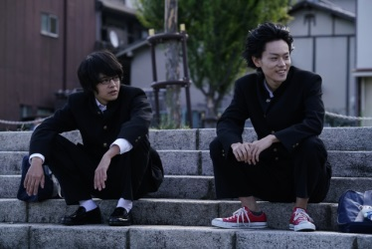

THE FILMS WILL BE SHOWN WITH ENGLISH SUBTITLES

|  |  |  |
| --- | --- | --- |
|  |  |  |

|  |  |  |
| --- | --- | --- |
|  |  |  |